**Test Plan: Sudoku**

|  |  |  |  |  |
| --- | --- | --- | --- | --- |
| **Test Case Number** | **Test Description** | **Expected Result** | **Actual Result** | **Pass/Fail** |
| 1 | Startup of application | GUI in ready state with no unexpected hardware issues or system failure. | Game begins | Pass |
| 2 | User initiated termination of application | Program terminated and all items are deconstructed. | Game ended by clicking exit or by closing the window | Pass |
| 3 | User starts the game by choosing a number from the list and input where appropriate | Number user chooses is inputted into the appropriate box | Number user chooses is inputted into the box of user choice | Pass |
| 4 | User enters number into box of choice where number belongs | Blue hint box should disappear once user enters number | User sees blue hint box disappear where number was entered | Pass |
| 5 | User can check progress by clicking the check button | User clicks check button, and it will display either green for correct or red for incorrect | User is displayed either green or red for the box where number was entered | Pass |
| 6 | User completes game by entering in all the numbers in the blank boxes | User clicks check button, and it will display all numbers in green that are correct and all numbers in red that are incorrect | All green numbers user has won game, or mixture of numbers user has not won game and must go back to correct red numbers | Pass |

**User Guide: Sudoku**

1. Select “Sudoku” from the main menu to initiate the game.

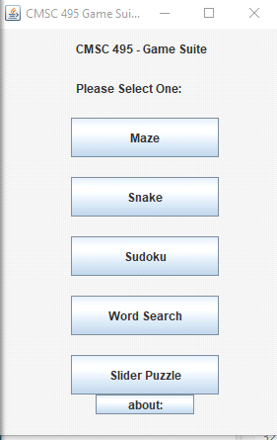

1. The game will open for the user to play:

* The user will be displayed 3 options “New” “Check” “Exit”
* New: will allow user to select a new game
* Check: will allow user to check answers
* Exit: will allow user to exit the game

1. A picture containing text, cabinet, screenshot

   Description automatically generatedUser will select a number ie. “1”. All the locations where a 1 can go will be displayed in blue. The user will be able to click on the box that they want the 1 to go. The blue display is annotated by the “Help on” check box. User can be able to turn on and off depending on if they want the help. User will proceed with each number with the same concept.
2. Calendar

   Description automatically generatedOnce number is entered by user the blue display boxes will go away and that number has been entered.
3. Calendar

   Description automatically generatedUser will be able to click the check button to see their progress and check the location of the numbers that were entered on the board.
4. Table

   Description automatically generatedLastly, end of the game showing that the user has completed the game. To start a new game user can click on the “New” button for another board to be displayed. To exit the game user will click “Exit” and the game will terminate.